Community Engagement

- February 2018 – Cumbrae Community Council newsletter to every door on the island asking them their general thoughts on the Island.

- April 2018 – Open meeting to deliver results of community engagement
Power point presentation available on request showing the Town Hall closure featured prominently in the replies received.
As a result of this the Friends of Millport Town Hall Steering Group was formed

The focus of the Steering Group became what was the want and need for the regeneration of this building. Would it be used? What would people like to see? Would people be prepared to help in the running of this facility? Would there be any displacement issues?

- July 2018 – Table Top Event . Consultation and information gathering. 60 conversations – 2 negative and 58 positive. Post it comments collated. Pre launch of CUMBRAE LOTTERY which is to help income for the Town Hall project.

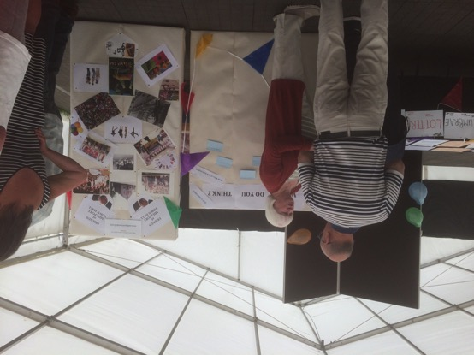

4. Sept 15 2018 - Consultation and social event.

NB IT SHOULD BE NOTED THERE WAS A STORM ON THE ISLAND THIS DAY! We did not expect anyone to attend.

25 comments received and suggestions. Social evening a complete sell out and £1320 raised.

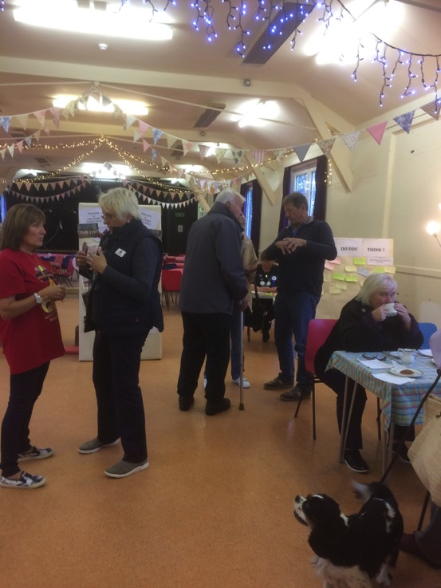
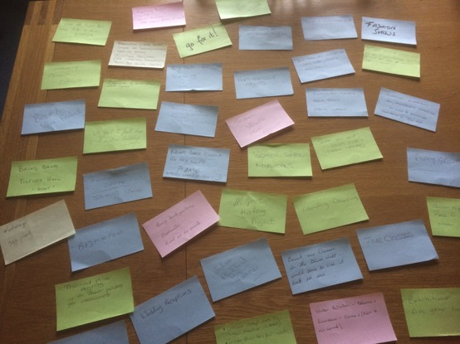

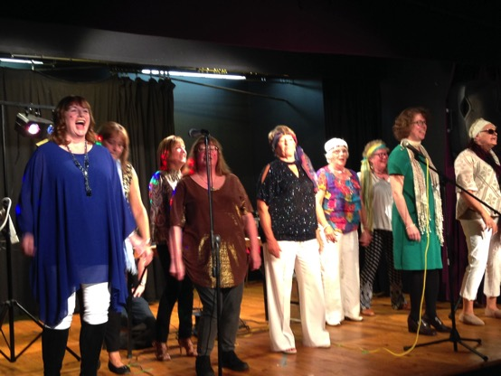

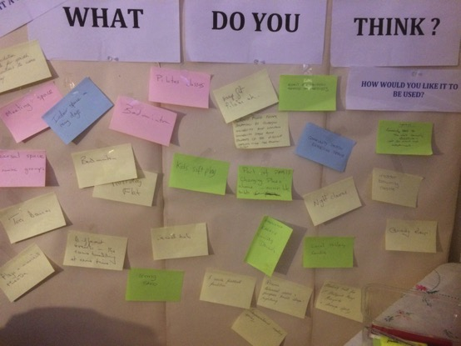

After the hut where the consultation/social event was held was locked up, two trees fell on the building. – our only public community space

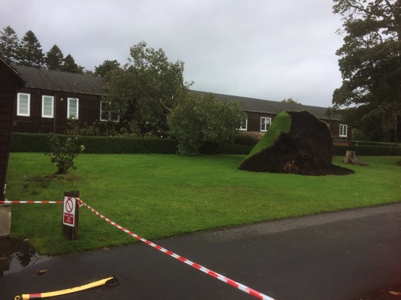

There is on going interaction with our Facebook page. We have received many messages of support, both local and as far afield as New Zealand.

Further consultation is planned to present the findings of our Feasibility Study.

Consultation during the Feasibility Study

Individuals, groups and island organisations were consulted during this study. Questions were asked surrounding support, concerns, whether the facility would be used by them and how.

Answers to these questions helped to inform the final concept design of a sustainable facility.

DISPLACEMENT ISSUES Care has been taken that there will be none. This is the reason there will be no café in the design as there is a successful café within Garrison House. The holiday flats will be two bed and high end – our investigations have indicated a lack of such facilities.

30 March – 2019

Presentation to community of the feasibility study results.

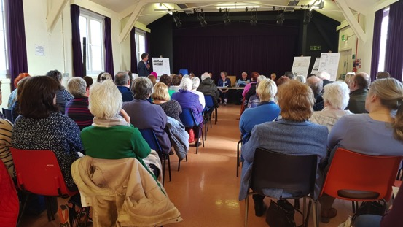

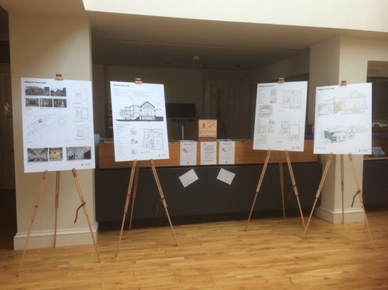

The plans were on public display the week prior to this presentation. 138 offers of voluntary help were received during this time. Some volunteers with relevant skills are working on this project now, others will become involved as the project progresses.

Twitter survey with 937 views and 93% in favour of Millport Town Hall Project

Survey Monkey with 97% in favour of Millport Town Hall Project

These two surveys asked very basic questions as they followed on from the Open Community Consultation that presented the findings of the Feasibility Study and was reported on in the local press:
- Do you support this Project?
- Would you use the facility?
- Would you consider volunteering?

14 July 2019

Community Tourist Association Event. General PR work with the public. Many leaflets taken for Cumbrae Lottery, badges sold.

Keen interest shown in developments by many and suggestions made for social media interactions. New volunteer recruited to help with future marketing.

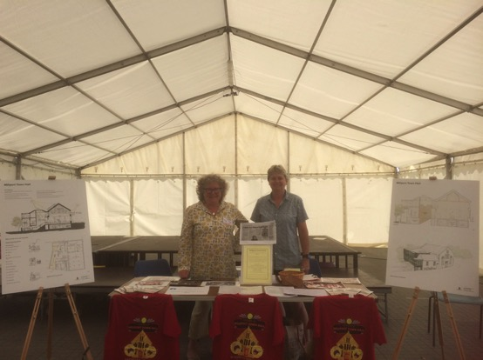

19 July 2019

Scottish Country Dancer’s Association – event held in Millport. This Association are suffering from the loss of their large venue. They endorse completely the Millport Town Hall Project and donated the proceeds from this event to our funds.
